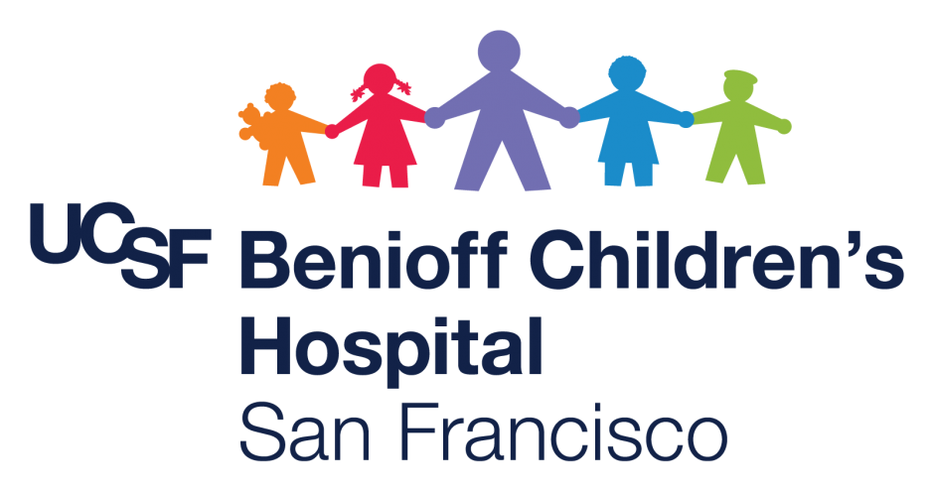

Hnub tim: Lub Kaum Hli 2022

Txog rau: Kashia Tsev Neeg

Koj tus kws kho mob tau hais kom koj tus me nyuam ntsuam xyuas cov txiaj ntsig tom qab mus saib. (Distribution Paperwork) los ntawm Lus Askiv rau Punjabi Thov txim uas koj tau txais qhov no tom qab lub sij hawm los tsev.

Yog tias koj muaj lus nug, koj tuaj yeem hu tau rau kuv ntawm (415) 476-8310.

Thov ua tsaug thiab kev saib xyuas.

Zoo Siab Txais Tos
Gabriela

Gabriela Quezada-Perez
Tus Saib Xyuas Tsev Kho Mob
UCSF Benioff Children’s Hospitals

C5 Medical-Surgical & Transitional Care Units
1975 4th Street | San Francisco, CA 94158
Voalt Lej Xov Tooj: 415.476.8310
gabriela.quezada-perez@ucsf.edu

